**LIRA UNIVERSITY**

**DEPARTMENT OF COMPUTER SCIENCE / COMPUTER EDUCATION**

**INTRODUCTION TO COMPUTER GRAPHICS**

**Lecture 1**

**COMPUTER GRAPHICS**

Introduction of Computer Graphics

Computer Graphics involves technology use to access, Process, transforms and presents information in a visual form. The role of computer graphics insensible. In today life, computer graphics has now become a common element in user interfaces, T.V. commercial motion pictures.

Computer Graphics is the creation of pictures with the help of a computer. The end product of the computer graphics is a picture it may be a business graph, drawing, and engineering.

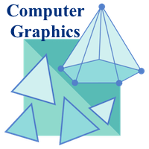

In computer graphics, two or three-dimensional pictures can be created that are used for research. Many hardware devices algorithm has been developing for improving the speed of picture generation with the passes of time. It includes the creation storage of models and image of objects. These models for various fields like engineering, mathematical and so on.

Today computer graphics is entirely different from the earlier one. It is an interactive; user can control the structure of an object of various input devices.

**Definition of Computer Graphics:**

It is the use of computers to create and manipulate pictures on a display device. It comprises of software techniques to create, store, modify, represents pictures.

**Why computer graphics used?**

Suppose a shoe manufacturing company want to show the sale of shoes for five years. For this vast amount of information is to store. So a lot of time and memory will be needed. This method will be tough to understand by a common man. In this situation graphics is a better alternative. Graphics tools are charts and graphs. Using graphs, data can be represented in pictorial form. A picture can be understood easily just with a single look.

Interactive computer graphics work using the concept of two-way communication between computer users. The computer will receive signals from the input device, and the picture is modified accordingly. Picture will be changed quickly when we apply command.

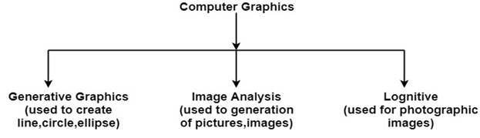

## Prerequisite

Good knowledge and understanding of the concepts of **C programming language** are necessary for learning the concepts of Computer graphics. Good understanding about basic mathematics allows us to better understand the concept of computer graphics.

## Audience

This course unit is helpful for the students who are interested in learning the use of graphics on the computer. The tutorial covers the basics of graphics and development of various visuals by the implementation of graphics in the computer.

# Application of Computer Graphics

**1. Education and Training:** Computer-generated model of the physical, financial and economic system is often used as educational aids. Model of physical systems, physiological system, population trends or equipment can help trainees to understand the operation of the system.

For some training applications, particular systems are designed. For example Flight Simulator.

**Flight Simulator:** It helps in giving training to the pilots of airplanes. These pilots spend much of their training not in a real aircraft but on the ground at the controls of a Flight Simulator.

### Advantages:

1. Fuel Saving
2. Safety
3. Ability to familiarize the training with a large number of the world's airports.

**2. Use in Biology:** Molecular biologist can display a picture of molecules and gain insight into their structure with the help of computer graphics.

**3. Computer-Generated Maps:** Town planners and transportation engineers can use computer-generated maps which display data useful to them in their planning work.

**4. Architect:** Architect can explore an alternative solution to design problems at an interactive graphics terminal. In this way, they can test many more solutions that would not be possible without the computer.

**5. Presentation Graphics:** Example of presentation Graphics are bar charts, line graphs, pie charts and other displays showing relationships between multiple parameters. Presentation Graphics is commonly used to summarize

* Financial Reports
* Statistical Reports
* Mathematical Reports
* Scientific Reports
* Economic Data for research reports
* Managerial Reports
* Consumer Information Bulletins
* And other types of reports

**6. Computer Art:** Computer Graphics are also used in the field of commercial arts. It is used to generate television and advertising commercial.

**7. Entertainment:** Computer Graphics are now commonly used in making motion pictures, music videos and television shows.

**8. Visualization:** It is used for visualization of scientists, engineers, medical personnel, business analysts for the study of a large amount of information.

**9. Educational Software:** Computer Graphics is used in the development of educational software for making computer-aided instruction.

**10. Printing Technology:** Computer Graphics is used for printing technology and textile design.

### Example of Computer Graphics Packages:

1. LOGO
2. COREL DRAW
3. AUTO CAD
4. 3D STUDIO
5. CORE
6. GKS (Graphics Kernel System)
7. PHIGS
8. CAM (Computer Graphics Metafile)
9. CGI (Computer Graphics Interface)

# Interactive and Passive Graphics

## (a) Non-Interactive or Passive Computer Graphics:

In non-interactive computer graphics, the picture is produced on the monitor, and the user does not have any controlled over the image, i.e., the user cannot make any change in the rendered image. One example of its Titles shown on T.V.

Non-interactive Graphics involves only one-way communication between the computer and the user, User can see the produced image, and he cannot make any change in the image.

## (b) Interactive Computer Graphics:

In interactive Computer Graphics user have some controls over the picture, i.e., the user can make any change in the produced image. One example of it is the Ping-Pong game.

Interactive Computer Graphics require two-way communication between the computer and the user. A User can see the image and make any change by sending his command with an input device.

### Advantages:

1. Higher Quality
2. More precise results or products
3. Greater Productivity
4. Lower analysis and design cost
5. Significantly enhances our ability to understand data and to perceive trends.

## Working of Interactive Computer Graphics:

The modern graphics display is very simple in construction. It consists of three components:

1. Frame Buffer or Digital Memory
2. A Monitor likes a home T.V. set without the tuning and receiving electronics.
3. **Display Controller or Video Controller:** It passes the contents of the frame buffer to the monitor.

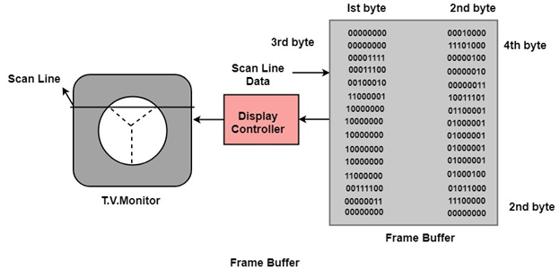

**Frame Buffer:** A digital frame buffer is large, contiguous piece of computer memory used to hold or map the image displayed on the screen.

* At a minimum, there is 1 memory bit for each pixel in the raster. This amount of memory is called a bit plane.
* A 1024 x 1024 element requires 220 (210=1024;220=1024 x 1024)sq.raster or 1,048,576 memory bits in a single bit plane.
* The picture is built up in the frame buffer one bit at a time.
* A memory bit has only two states (binary 0 or 1), a single bit plane yields a black and white (monochrome display).
* As frame buffer is a digital device write raster CRT is an analog device.

### Properties of Video Monitor:

**1. Persistence:** Persistence is the duration of phosphorescence. Different kinds of phosphors are available for use in CRT. Besides color, a major difference between phosphor in their persistence how they continue to emit light after the electron beam is removed.

**2. Resolution:** Use to describe the number of pixels that are used on display image.

**3. Aspect Ratio:** It is the ratio of width to its height. Its measure is unit in length or number of pixels.

Aspect Ratio =Interactive and Passive Graphics

End of Lecture 1